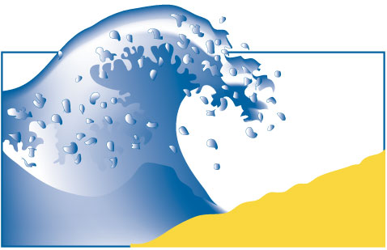
Department of Earth & Environment
Florida International University, Miami, FL

Phone: 305-238-5888
Website: www.DrBeach.org

“Dr. Beach” Names St. George Island
State Park as America’s Best Beach
TOP 10 BEACHES 2023

- St. George Island State Park
Florida Panhandle
- Duke Kahanamoku Beach
Oahu, Hawaii
- Coopers Beach
Southampton, New York
- Caladesi Island State Park
Dunedin/Clearwater, Florida
- Lighthouse Beach, Buxton
Outer Banks of North Carolina
- Coronado Beach
San Diego, California
- Wailea Beach, Maui, Hawaii
- Beachwalker Park
Kiawah Island, South Carolina
- Poipu Beach, Kauai, Hawaii
- Coast Guard Beach
Cape Cod, Massachusetts

Miami, FL—St. George is the number one ranked beach in the 33rd annual Top 10 Beach List, produced by coastal expert Dr. Stephen P. Leatherman, professor in the Department of Earth & Environment at Florida International University in Miami.

St. George Island State Park on Florida’s Gulf Coast is a favorite destination for beachgoers, anglers and bird watchers. The park offers nine miles of some of the most pristine beach in the United States. Its remote location is perfect for stargazing and enjoying spectacular sunsets. Camping in this 1,962-acre barrier island park is available for nature enthusiasts. A climb to the top of St. George Island Lighthouse offers an excellent view of this offshore island and village where accommodations are available. There are ample opportunities for sunbathing, beachcombing, swimming, canoeing, kayaking, hiking and nature study.

As “Dr. Beach” (www.DrBeach.org), Leatherman has selected the annual Top 10 Beaches since 1991. Fifty criteria are used to evaluate beaches, which include water and sand quality as well as safety and management. Dr. Leatherman is an internationally known coastal scientist who has published 20 books and hundreds of scientific articles and reports about storm impacts, coastal erosion and ways to improve beach health and safety.

Bonus points are awarded for prohibition of smoking on beaches, and Florida joined the list of growing states that recognizes the importance of keeping their beaches clear of cigarette butts. Miami Beach was among the first to prohibit smoking on this world-famous beach.

Previous National Winners are retired and listed on his web site.

Additional Online Resources:
Biography for Dr. Stephen P. Leatherman: www.drbeach.org/pressrelease/leathermancv

Photographs: Available on request
Dr. Beach’s 50 Criteria: www.drbeach.org/fiftycriteria

